Exercise 1: Setting Up JUnit (JUnit 5 using Maven in VS Code)

Objective
Configure a Maven project with JUnit 5, create a test class, and verify that the project is ready for unit testing. Set up a Java project to start writing unit tests using JUnit 5 and Maven in Visual Studio Code.

Software Used
- Visual Studio Code
- Java JDK 17
- Apache Maven
- JUnit 5 (JUnit Jupiter 5.10.2)

Steps Performed
- Created a new Maven Java project in Visual Studio Code.
- Opened the generated pom.xml file.
- Added the JUnit 5 dependency.
- Added the Maven Surefire Plugin.
- Created CalculatorTest.java under src/test/java/com/example.
- Implemented a simple JUnit 5 test using @Test and assertEquals().
- Ran the test successfully.

JUnit 5 Dependency
<dependency>
<groupId>org.junit.jupiter</groupId>
<artifactId>junit-jupiter</artifactId>
<version>5.10.2</version>
<scope>test</scope>
</dependency>
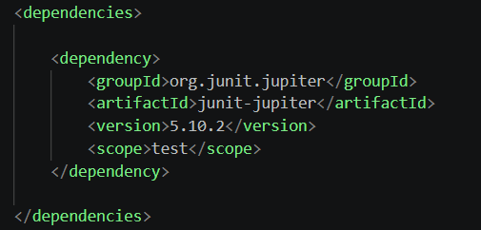

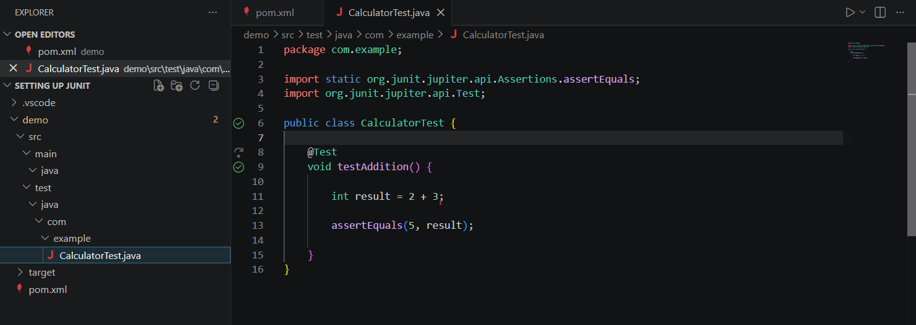

CalculatorTest.java
package com.example;
import static org.junit.jupiter.api.Assertions.assertEquals;
import org.junit.jupiter.api.Test;
public class CalculatorTest {
@Test
void testAddition() {
int result = 2 + 3;
assertEquals(5, result);
}
}

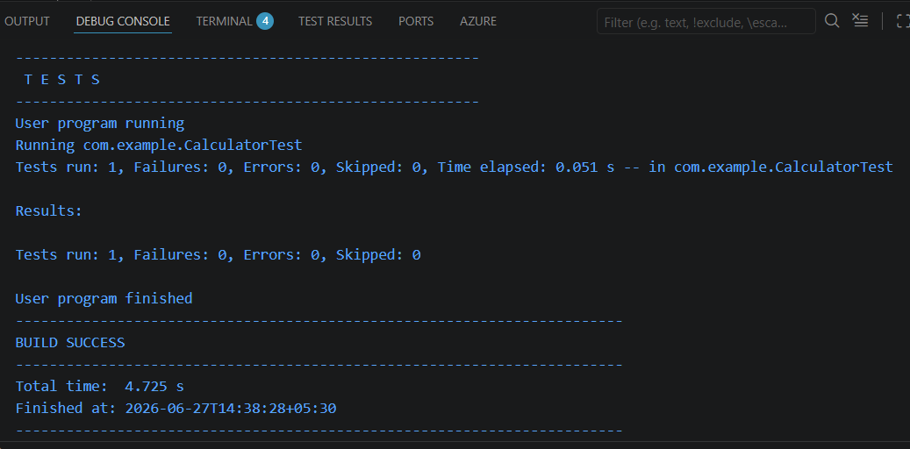

Expected Output
Tests run: 1
Failures: 0
Errors: 0
Skipped: 0
BUILD SUCCESS

